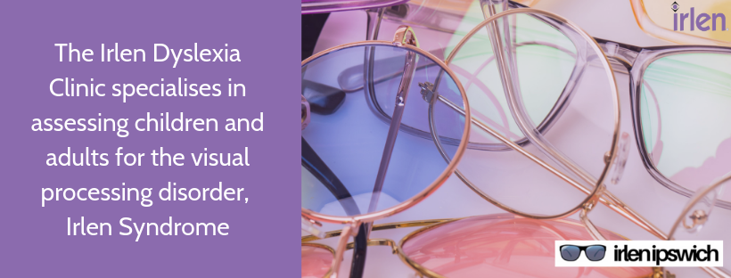

IRLEN TRAINING COURSES:

Welcome:
Irlen Syndrome has a lot to do with the vision system, but not with eyesight. In some people light interferes with the brain's ability to process visual information. This is sometimes referred to as "visual perceptual difficulties" or "visual processing difficulties". When we see things clearly, it is easy to assume that everyone else does also. This is not always the case. Research tells us that 15% of the general population (and 50% of the reading disabled population) have moderate to severe problems with seeing print, people's faces and the environment in a normal way. (See the distortions page.) This is often accompanied by eyestrain, difficulty focusing, light sensitivity, headaches or migraines, depth perception, inefficient reading, poor spelling, and a reluctance to write.

Research was initiated in the 1980’s to study methods of helping adults and children with unresolved learning and reading problems. This research revealed that certain individuals showed a marked improvement in their ability when reading material covered by a colored overlay. Helen Irlen developed a diagnostic assessment instrument to accurately determine those individuals who could benefit from reading using color. The Irlen Method provides a real solution that works simply and effectively. It can be easily incorporated into the educational/clinic/health centre settings and as part of an assessment battery.

LEVELS OF INVOLVEMENT:

There are three levels of involvement in the Irlen organization.

*The first is at a pre-assessment level (Pre-Assessment for Scotopic Sensitivity - PASS).
There is a short training Session. It is easy to administer. The manual shows exactly what to do and what to say. The student ends up with a score and this indicates the severity. The cost involved is for the materials and training. A typical application would be a learning support or special education teacher checking out what learning difficulties a student has.
*The second level is as a Screener. The training for this is conducted over 10+ individual sessions. This is much more involved than PASS level and goes into a deeper understanding and requires more skills (which are taught in the course). When conducting a screening on a student, there is a definite structure and procedure to be followed. The course is based on the cost of the materials, which are sourced from the United States. As a screener, you are entitled to charge for each screening assessment. If the screening indicates IS/SSS then the student would be referred on the local Irlen Clinic or the Diagnostician in your area. Certain basic professional qualifications are required.

*The third level is as a Diagnostician and this requires further training supervised by the Irlen Institute in California. This person would need to be an experienced screener. The Irlen Institute requires that to train as a Screener or a Diagnostician, formal qualifications are necessary. eg. a Degree in Education or Psychology

PASS TRAINING COURSE:

PRESENTER: Dianne Bevan, B.A, Dip. Teaching, M.ED, Gr.Dip.Mental Health, M.A.A.I.C.

COST: TRAINING + SCREENING KIT + 2 SET OF TRANSPARENCIES : $500
For extra attendees – only cost is: Extra kit ($50), 1 Set of transparencies ($100)

At the completion of the course Teachers will be aware of what to look for and how they can cater for these students in their classrooms.

The Presentation includes familiarizing Teachers with the testing procedures.

On the purchase of a Screening Kit, Selected Teachers can be certified as Pre-assessors for Irlen Syndrome and can screen students at their school.

_____________________________________________________________________________________

Dear Colleague,

If you are interested in attending a PASS training course, please fill out the form below and return to the Irlen Dyslexia Clinic – Ipswich: Email:diannebevan21@gmail.com

Name:_____________________________ Mobile Number: ___________________

Address:__________________________________________Postcode:__________

Location: (eg. Ipswich District) ___________________________________________

Occupation: __________________________ E-mail: _________________________

Qualifications: _______________________________________________________

Signed: ___________________________________Date: ____________________

SCREENER TRAINING COURSE:
The training for this is around 10 + hours (includes individual readings/personal training). This course is specifically designed for educators, learning specialists, reading or resource specialists, school psychologists, speech-language therapists, chiropractors, rehab counselors, vision care specialists, occupational therapists, counselors, learning specialists, allied health professionals, OT’s, optometrists, tutors, and educational therapists.
Once you become a certified Irlen Screener you can add this service to your existing educational, OT, SLP, psychological, health or tutoring practice and services (Currently screeners earn $160 per screen). If the screening indicates IS/SSS then the student would be referred on the local Irlen Clinic or the Diagnostician in your area.

As well, you become part of an international network of professionals who help maximize educational, work, and daily activity performance for children and adults with reading problems, dyslexia, ADD/ADHD, chronic migraines/headaches, light sensitivity, anxieties, autism, and sensory processing disorders.

Over 10 hours you will learn:
- How to identify individuals with Irlen Syndrome
- The common learning and behavioral characteristics of individuals with Irlen Syndrome
- How perception affects reading, spelling, mathematics and copying
- How perception can affect depth perception and sensory integration
- How to test using the Irlen Reading Perceptual Scale (IRPS)
- A variety of intervention strategies including colored overlays
- Hands-on practice using the IRPS
- About international research on Irlen Syndrome
Upon successful completion of the course, participants will be certified through the Irlen® Institute to diagnose Irlen® Syndrome/Scotopic Sensitivity and properly prescribe Irlen® Spectral Overlay Filters for stage one remediation. Participants will become competent to assess the severity of Irlen® Syndrome and learn whom to refer to for the next, more comprehensive diagnostic assessment.

Course Outline: A mixture of Individual & session work

The screener training course is structured as follows:
- The Irlen Method. Facts and definitions.
- How Discovered.
- Populations which benefit.
- Mind Body connections – stressors.
- Research.
- Training in administering the instrument (IRPS).
- Review of screeners handbook
- Scoring and interpretation
- Classroom modifications
- Spreading the word
- Web sites
FOLLOW-UP (After trainee has completed 10 individual screenings)
- Complete evaluation form
- Screen 10 clients (try to do a couple of adults, and a couple of people who do not have Irlen Syndrome).
These books need to be purchased from Irlen.com or Amazon
1. Reading by the Colours (Helen Irlen)
2. The Irlen Revolution. (Helen Irlen)
3. Sports concussion & Getting Back in the Game of Life (Helen Irlen)

Dyslexia Clinic

32 Chalmers Place,
North Ipswich, Qld 4305
Ph: 0421310768
Email:diannebevan@hotmail.com
facebook.com/IrlenDyslexiaClinicIpswich
www.irlenipswich.com.au

IRLEN SCREENER APPLICATION:

Requirements for Training: You must;
1. Have a teaching certificate or graduate degree in education, psychology, counselling, speech, occupational therapy or rehabilitation, health or medical field, or experience working with a literacy program.
2. Have at least 2 years of experience in that field.
3. Provide a resume outlining your educational background and work history.

Credentials and a formal resume must be submitted with your application, reviewed and accepted prior to enrolment.

The course costs $950 and is based on the cost of materials and time taken to train.
This will include;
- 10+ hours training and support
- Screener Training folder (contains process outline, forms, sample reports, cards (Chart, Box A, Box B etc), research docs., dyslexia section, order forms and flyers as set out by Helen Irlen.
- Screener Manual
- 2x sets of overlays
- Parent & Teacher Toolkits (Download from Irlen Syndrome Foundation)
- Postage & Handling

Competencies for Screener Training
1. Must have proof of eligibility for registration in their discipline.
2. Must attend and complete an Irlen Screening training course.
3. Must supply 10 completed IRPS forms to their trainer and receive their Certificate.
4. Must provide screenings to clients
5. Must provide results of screenings to clients
6. Maintain a register of continuing education

Dyslexia Clinic

32 Chalmers Place,
North Ipswich, Qld 4305
Ph: 0421310768
Email:diannebevan@hotmail.com
facebook.com/IrlenDyslexiaClinicIpswich
www.irlenipswich.com.au

Dear Colleague,

If you are interested in attending a Screener training course, please fill out the form below and return to the above address.

Name: ______________________________________________________________

Address: ___________________________________________Postcode:__________

Mobile: _______________________________

Location: (eg. Ipswich District) ________________________________________

E-mail: ________________________________________

Qualifications:__________________________________________________________________

_____________________________________________________________________________

Occupation: ___________________________________________________________________

Signed: _____________________________________Date: _____________________________

