IRLEN DYSLEXIA CLINIC IPSWICH
124 Haig Street, Brassall QLD 4305 | 0421 310 768
diannebevan21@gmail.com | facebook.com/IrlenDyslexiaClinicIpswich | www.irlenipswich.com.au
IRLEN SCREENER TRAINING & APPLICATION
Information for prospective Irlen Screeners

1. Purpose of the Training
This program prepares eligible professionals to conduct structured Irlen screenings using the Irlen Reading Perceptual Scale (IRPS), communicate screening results appropriately, and refer clients for comprehensive assessment when indicated.

2. About Irlen Syndrome and Visual Processing Difficulties
Some people experience difficulties with visual processing when reading, working with print or interacting with their visual environment, even when eyesight itself may not fully explain their difficulties. These experiences may be described as visual perceptual or visual processing difficulties.
Reported characteristics may include discomfort when reading, visual distortions, light sensitivity, eyestrain, difficulty sustaining focus, headaches or migraines, and reduced efficiency with reading, spelling, copying or written work.
The Irlen Method developed from work begun in the 1980s exploring the effects of colour on visual comfort and reading for some children and adults experiencing persistent learning or reading difficulties.
The method is used alongside, and not as a replacement for, appropriate educational, health and vision care. An IRPS screening identifies reported characteristics and their severity within the screening framework; it does not provide a diagnosis of Irlen Syndrome.

3. The Role of an Irlen Screener
An Irlen Screener provides a structured screening service using the IRPS. The Screener gathers relevant information, administers the screening process, records and interprets findings within the training framework, and discusses the outcome with the client or parent/carer, as appropriate.
Where screening findings indicate that further investigation may be helpful, the Screener refers the client to a local Irlen Clinic or appropriately qualified Diagnostician for comprehensive assessment.
Screeners do not diagnose Irlen Syndrome or provide a comprehensive diagnostic assessment.

4. Eligibility and Entry Requirements
Applicants must meet the following requirements before enrolment:
- Hold a teaching certificate or a graduate degree in education, psychology, counselling, assessment, speech-language therapy, occupational therapy, rehabilitation, health or a medical field; alternatively, have relevant literacy-program experience, including work in a prison literacy program.
- Have at least two years of experience in the relevant field.
- Provide a current resume outlining educational background and work history.
- Provide credentials demonstrating eligibility for registration in their professional discipline, where applicable.
Applicants must submit their resume and supporting credentials for review. Enrolment is confirmed only after the application has been reviewed and accepted.

5. Training at a Glance
Training component | Details
Part 1 – Online Course | All new Irlen Screeners must complete the required online training course before commencing Part 2. The course can be completed in less than one day and is provided free of charge to both trainers and trainees.
Part 2 – Live Training | Approximately 10+ hours of guided learning, practical work and support, delivered over two days, either in person or online with the trainer.
Course fee | $1,000
Training format | Guided learning, individual reading, practical IRPS administration, overlay instruction and supervised practice.
Completion certificate | Trainees must complete Part 1 and receive a certificate. The trainer must sight the certificate before the trainee can participate in Part 2. Trainees must also provide their certificate to the Irlen Institute through the training sign-in form.

Part 1 – Online Course
The course provides consistent, up-to-date training information and covers the information and instructions required for Screener training.
- The course can be completed in less than one day.
- There is no cost to trainers or trainees.
- Trainees must complete all modules and receive a completion certificate before attending Part 2.
- Trainers must sight the certificate before allowing trainees to participate in Part 2.
- Trainees must also provide their certificate to the Irlen Institute through the training sign-in form.
The online course does not include overlay instruction or practical opportunities to practise task administration. These components are covered during Part 2.

Part 2 – Live Training
Part 2 consists of approximately 10+ hours of guided learning and practical work delivered over two days, either in person or online with the trainer.
Training component | Content
IRPS scoring | A brief review of scoring procedures.
Task administration | A brief review of Box A, Box B and Pumpkin administration.
Practical task practice | Opportunities to practise Box A, Box B and Pumpkin.
Overlay instruction | Overlay instruction and practical practice.
Complete screening | An opportunity to administer a complete screening from beginning to end with a partner.

Assistance with accessing the course or arranging a meeting to review the process may be requested from the Irlen Institute.

6. Learning Outcomes
During the training, participants develop the knowledge and practical skills to:
- Recognise common learning, behavioural and visual-perceptual characteristics that may warrant screening.
- Understand how visual processing may affect reading, spelling, mathematics, copying, depth perception and sensory integration.
- Administer the IRPS in accordance with the Screener Manual and training procedures.
- Score and interpret IRPS responses to identify characteristics and severity within the screening framework.
- Recognise reported visual distortions, light sensitivity and related reading or perceptual concerns.
- Consider practical classroom, workplace and everyday support strategies, including the appropriate use of coloured overlays.
- Communicate screening results clearly and sensitively, identifying when referral for comprehensive assessment is appropriate.
- Apply the screening process confidently through supervised hands-on practice.

7. Training Structure
The course combines guided learning, individual reading and practical sessions. Content includes:
- The Irlen Method: background, facts and definitions.
- How the method was developed, populations that may benefit, relevant research and mind-body connections, including stressors.
- Review of the Screener Manual and structured IRPS process.
- IRPS administration, scoring, interpretation and documentation.
- Classroom and workplace considerations, communication and referral pathways.
- Professional practice, outreach resources and relevant websites.
- Practical screening exercises and supervised administration.
Part 1 provides the required online learning. Part 2 focuses on reviewing key procedures, developing practical skills and practising screening administration over two days.

8. Training Materials Included
The course fee includes the following training package:
Training material | Description
Screener Manual USB | Includes the process outline, forms, sample reports, research documents, dyslexia information, order forms and flyers.
IRPS forms | 12 original forms.
Irlen Chart | One chart.
Overlay sets | Two sets.
Parent & Teacher Toolkits | Downloadable from the Irlen Syndrome Foundation.
Reading by the Colours | Helen Irlen.
The Irlen Revolution | Helen Irlen.
Sports Concussion & Getting Back in the Game of Life | Helen Irlen.

9. Competency and Post-Training Requirements
Certification is issued after the participant has met the applicable training and competency requirements.
To complete the certification process, a trainee must:
- Complete Part 1, the required online course, before participating in Part 2.
- Provide the online course completion certificate as required.
- Complete Part 2, including the required practical training.
- Complete 10 individual screenings using the IRPS, including a range of client presentations where practicable, such as adults and clients whose screening does not indicate Irlen-related characteristics.
- Submit all 10 completed IRPS forms to the trainer for review, together with any other required documentation.
- Meet the certificate requirements advised by the trainer.
- Demonstrate appropriate communication of screening outcomes to clients and parents/carers.
- Provide screening services within the scope of the Screener role.
- Maintain a record of continuing education and undertake ongoing professional development as required.
Completion of Part 1 alone does not qualify a participant for certification. Part 2, the required 10 IRPS screenings and review of the completed forms must also be completed.

10. Referral and Professional Responsibilities
A screening result forms only one part of a client's broader picture. Screeners must work within their own professional scope, maintain secure records, communicate with appropriate consent, and recommend other relevant educational, health or vision care where needed.
Clients whose screening findings suggest a need for comprehensive Irlen assessment should be referred to a local Irlen Clinic or appropriately qualified Diagnostician.
Screeners must not represent screening findings as a diagnosis or suggest that screening replaces appropriate professional assessment.

IRLEN SCREENER APPLICATION
Please complete this form and return it with your current resume and supporting credentials to the clinic contact details provided on page one.

Applicant Details
Full name: __________________________________________________________________
Age: ____________
Gender: ☐ Female ☐ Male ☐ Non-binary ☐ Prefer not to say ☐ Self-describe: __________________
Address: ____________________________________________________________________
Suburb/Town: __________________________________________ Postcode: __________
Mobile: ______________________________ Email: ________________________________

Professional Background
Qualifications:
____________________________________________________________________________
____________________________________________________________________________
____________________________________________________________________________
Current occupation / professional role:
____________________________________________________________________________
Professional registration or relevant credentials, if applicable:
____________________________________________________________________________
Relevant professional experience:
____________________________________________________________________________
____________________________________________________________________________

Supporting Documents
Please attach:
- A current resume outlining your educational background and work history.
- Copies of relevant qualifications and professional credentials.
- Any further information supporting your eligibility for Irlen Screener training.
Applications will be reviewed before enrolment is confirmed. Applicants must provide the required supporting documentation to demonstrate eligibility.

Applicant Declaration
I confirm that the information supplied in this application is accurate. I understand that enrolment is subject to review and acceptance of my application, resume and supporting credentials.
I understand that Irlen Screener training prepares me to conduct IRPS screenings and make referrals for comprehensive assessment when indicated. I understand that the training does not authorise me to diagnose Irlen Syndrome.
I understand that I must complete Part 1 and provide the required completion certificate before participating in Part 2. I also understand that certification is subject to completion of the two-day live training, the required 10 IRPS screenings and submission of the completed forms to the trainer for review.
Signature: __________________________________________ Date: __________________

The Irlen Team

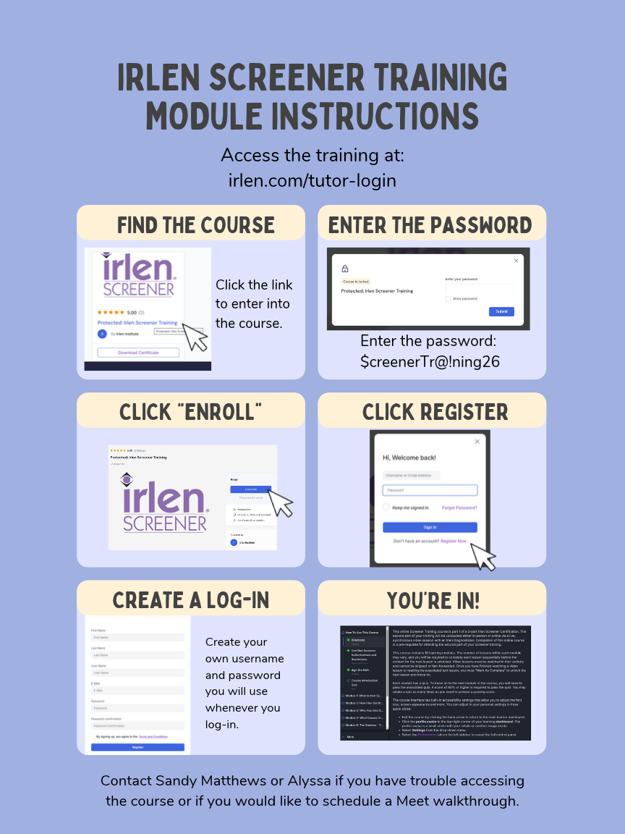

Clinic Use Only
Administrative requirement | Status
Application received | ☐ Yes ☐ No
Eligibility reviewed | ☐ Accepted ☐ Further information required
Resume received | ☐ Yes ☐ No
Supporting credentials received | ☐ Yes ☐ No
Part 1 completion certificate sighted | ☐ Yes ☐ No
Part 2 live training completed | ☐ Yes ☐ No
10 completed IRPS forms submitted and reviewed | ☐ Yes ☐ No
Certification requirements met | ☐ Yes ☐ No

Trainer's name: ______________________________________________________________
Trainer's signature: _____________________________________ Date: ______________

